springboot-best-practices

**Notable Mentions**

1. Create application.yml for each environment. For example: application-dev.yml, application-prod.yml ...
2. Use a library to map DTOs, such as MapStruct.
3. Use soft delete.
4. Use environment variables to avoid hard-coding

**1. Proper packaging style**

* You can structure your application with meaningful packaging.
* Proper packaging will help to understand the code and the flow of the application easily.
* You can include all your controllers into a separate package, services in a separate package, util classes into a separate package…etc. This style is very convenient in small-size microservices.
* If you are working on a huge code base, a feature-based approach can be used.
* You can decide which to adopt,
* depending on your requirements.

Based on type:

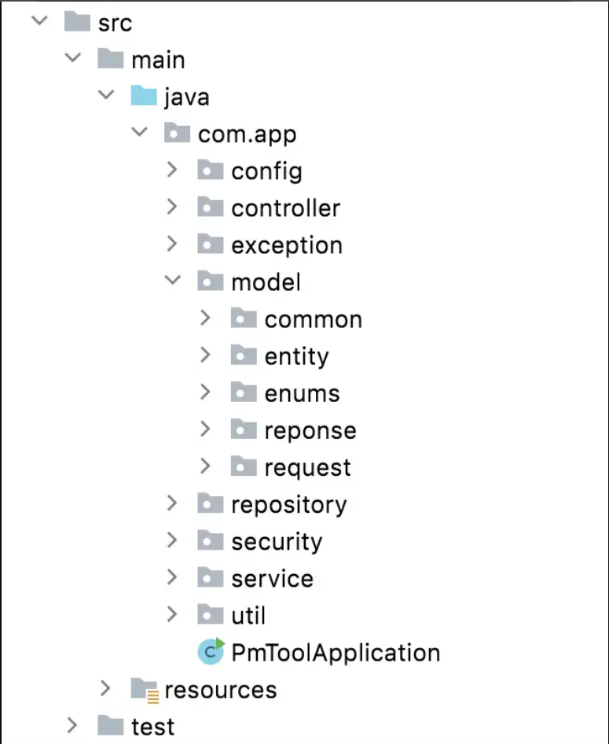

Based on feature:

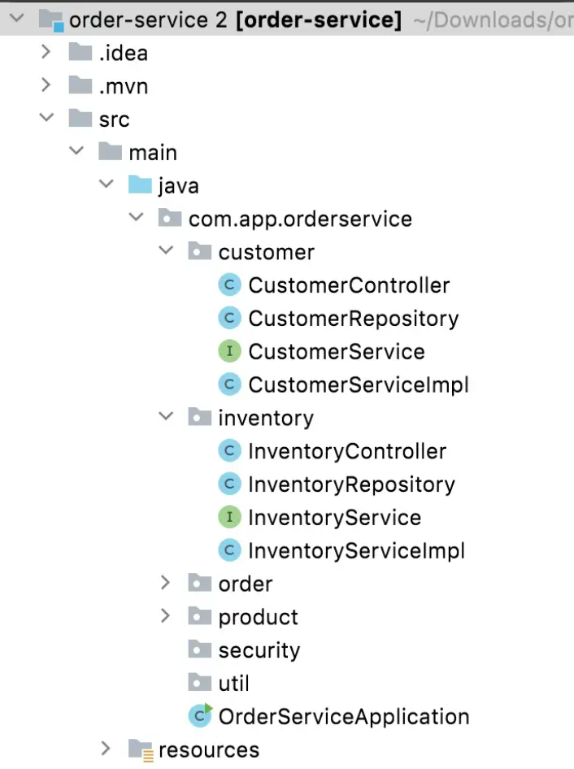

**2. Use Spring Boot starters**

* We can very easily use starter dependencies without adding single dependencies one by one. These starter dependencies are already bundled with the required dependencies.
* Can add these easily using Spring Initializr.
* For example, if we add spring-boot-starter-web dependency, by default it is bundled with jackson, spring-core, spring-mvc, and spring-boot-starter-tomcat dependencies.
* As a result, we don’t need to care about adding dependencies separately.
* Also, it helps us to avoid version mismatches.

**3. Use proper versions of the dependencies**

* It is always recommended to use the latest stable GA (General Availability) versions.
* Sometimes it may vary with the Java version, server versions, the type of the application, etc.
* Do not use different versions of the same package and always use <properties> to specify the version if there are multiple dependencies. For example:

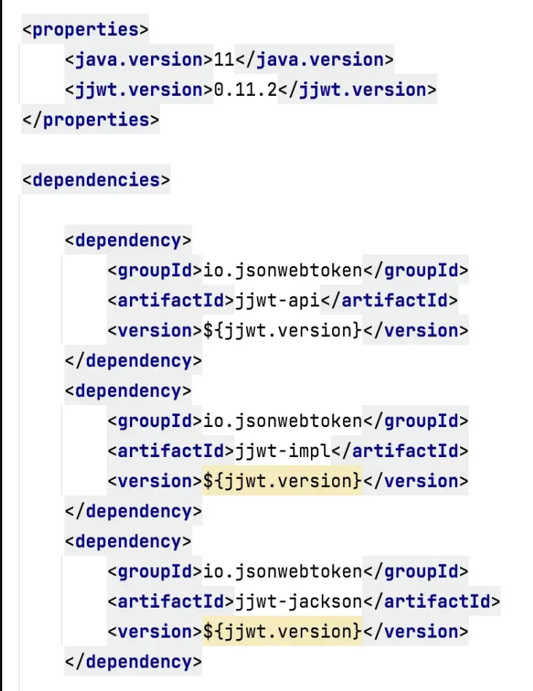

**4. Use Lombok**

* Lombok is a Java library that is used to reduce boilerplate code and allow you to write clean code using its annotations.
* For example, you may use plenty of lines for getters and setters in some classes like entities, request/response objects, dtos…etc.
* But if you use Lombok, it is just one line, you can use @Data, @Getter or @Setter as per your requirement.
* You can use Lombok logger annotations as well. @Slf4j is recommended.

**5. Use Controllers only for routing**

* Controllers are dedicated to routing.
* It is stateless and singleton.
* The *DispatcherServlet* will check the @RequestMapping on Controllers.
* Controllers are the ultimate target of requests, then requests will be handed over to the service layer and processed by the service layer.
* The business logic should not be in the controllers.

**6. Use Services for business logic**

* The complete business logic goes here with validations, caching…etc.
* Services communicate with the persistence layer and receive the results.
* Services are also singleton.

**7. Use constructor injection with Lombok**

* When we talk about dependency injection, there are two types.
* One is “constructor injection” and the other is “setter injection”. Apart from that, you can also use “field injection” using the very popular @Autowired annotation.
* But we highly recommend using Constructor injection over other types. Because it allows the application to initialize all required dependencies at the initialization time.
* This is very useful for unit testing.
* The important thing is, that we can use the @RequiredArgsConstructor annotation by Lombok to use constructor injection.

**8. Use Slf4j logging**

* Logging is very important.
* If a problem occurs while your application is in production, logging is the only way to find out the root cause.
* Therefore, you should think carefully before adding loggers, log message types, logger levels, and logger messages.
* Do not use System.out.print()
* Slf4j is recommended to use along with logback which is the default logging framework in Spring Boot.
* Always use slf4j { } and avoid using String interpolation in logger messages. Because string interpolation consumes more memory.
* You can use Lombok @Slf4j annotation to create a logger very easily.
* If you are in a micro-services environment, you can use the ELK stack.

**9. Use meaningful words for classes, methods, variables and other attributes**

* Always use proper meaningful and searchable naming conventions with proper case.
* Usually, we use nouns or short phrases when declaring classes, variables, and constants. For example: String firstName, const isValid
* You can use verbs and short phrases with adjectives for functions and methods. For example: readFile(), sendData()
* Avoid using abbreviating variable names and intention revealing names. For example: int i; String getExUsr;
* If you use this meaningfully, declaration comment lines can be reduced. Since it has meaningful names, a fresh developer can easily understand by reading the code.
* There are many different case styles we can adopt but, we must identify which case is dedicated to which variable and be consistent with it. Most common standard:

Classes = PascalCase  
Methods & Variables = camelCase  
Constants = SCREAMING_SNAKE_CASE  
DB-related fields = snake_case

**10. Bean Validation**

* Apply to DTOs.
* Use annotations such as @NotBlank, @Min, @Max, and add messages to each.
* Use @Valid in Controller POST request method attributes to validate against the DTO bean validation annotations.

NOTE: Use the annotations from javax.persistence._ for adding constraints in the Model/Entity layer.  
NOTE: Use the annotations from javax.validation.constraints._ for adding validation in the DTO layer.

**11. Custom Exception Handling**

* This is very important when working with large enterprise-level applications.
* Apart from the general exceptions, we may have some scenarios to identify some specific error cases.
* Exception adviser can be created with @ControllerAdvice, and we can create separate exceptions with meaningful details.
* It will make it much easier to identify and debug errors in the future.

**12. Use custom response object**

* A custom response object can be used to return an object with some specific data with the requirements like HTTP status code, API code, message, etc.

**13. Use design patterns**

* Know **when** and **where** to use *which* pattern.
* Builder and Singleton most used in Spring Boot applications.

**14. Use yml instead of properties**

* Less repetition/duplication of the key prefix.
* More readable.
* Also, use comments in config file to separate which settings belong to which feature.

**15. Encrypt or externalize sensitive info**

* Encrypt ALL passwords (never store as plain text).
* Move this information outside the codebase (Vault, git server, cloud config, etc.)

**16. Write E2E Unit Test cases with coverage**

* This is done to validate that all features and API's are working as expected.
* Why do we mock Repository/Service? We do not want the test data to save to the DB, so mocking the behaviour of methods helps us bypass DB interactions.
* Test ALL endpoints/methods.
* Test positive AND negative scenarios for each endpoint. Include Edge Cases!
* Running the code with Coverage allows us to identify which parts of the code have or have not been tested.
* Aim for 100% coverage!

**17. Avoid NPE by using Optional**

* In Java 8, to avoid NullPointerException you can use Optional from java.util.package.

**18. Use best practices for the collection framework**

* Use appropriate collection (data structure) for your data set.
* Use forEach with Java 8 features and avoid using legacy for loops.
* pre- and post-Java 8 comparison:

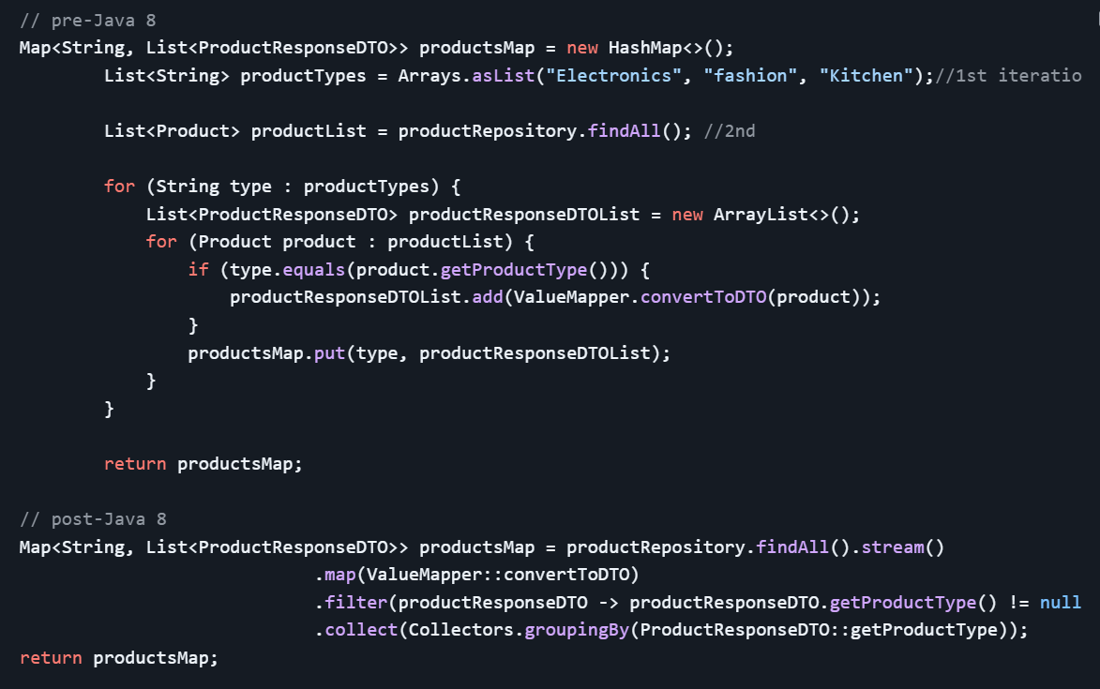

* Functional programming is better for performance and readability.
* Use interface type instead of the implementation.
* Use isEmpty() over size() for better readability.
* Do not return null values, you can return an empty collection.

**19. Use Caching**

* Caching is another important factor when talking about application performance.
* It reduces the round trip of your request from your application to the DB (if no changes were detected).
* By default, Spring Boot provides caching with ConcurrentHashMap and you can achieve this by @EnableCaching annotation.
* If you are not satisfied with default caching, you can use Redis, Hazelcast, or any other distributed caching implementations.
* Redis and Hazelcast are in-memory caching methods. You also can use database cache implementations as well.

**20. Use Pagination**

* This is useful if you have lots of records, it allows us to view the data more easily.
* This will improve the performance of the application.
* If you’re using Spring Data JPA, the PagingAndSortingRepository makes using pagination very easy and with little effort.

**21. Remove unnecessary codes, variables, methods**

* Unused variable declarations will acquire some memory.
* Remove unused methods, classes, imports, vars etc. because it will impact the performance of the application.
* Try to avoid nested loops. You can use Java 8 Streams instead.

**22. Use Comments**

* Commenting is a good practice unless you abuse it.
* DO NOT comment on everything. Instead, you can write descriptive code using meaningful words for classes, functions, methods, variables…etc.
* Remove commented codes, misleading comments, and story-type comments.
* You can use comments for warnings and explain something difficult to understand at first sight.
* Example of comment explaining a method:

**23. Use a common code formatting style**

* Have a consistent and uniform way of formatting your code.
* Use spaces and/or returns in an ordered and readable manner.
* CMD+OPTION+L on highlighted code in IDE for code reformatting!
* Can see below, two different ways of formatting the same code. To avoid discrepancies, you or your team should have a common coding format.

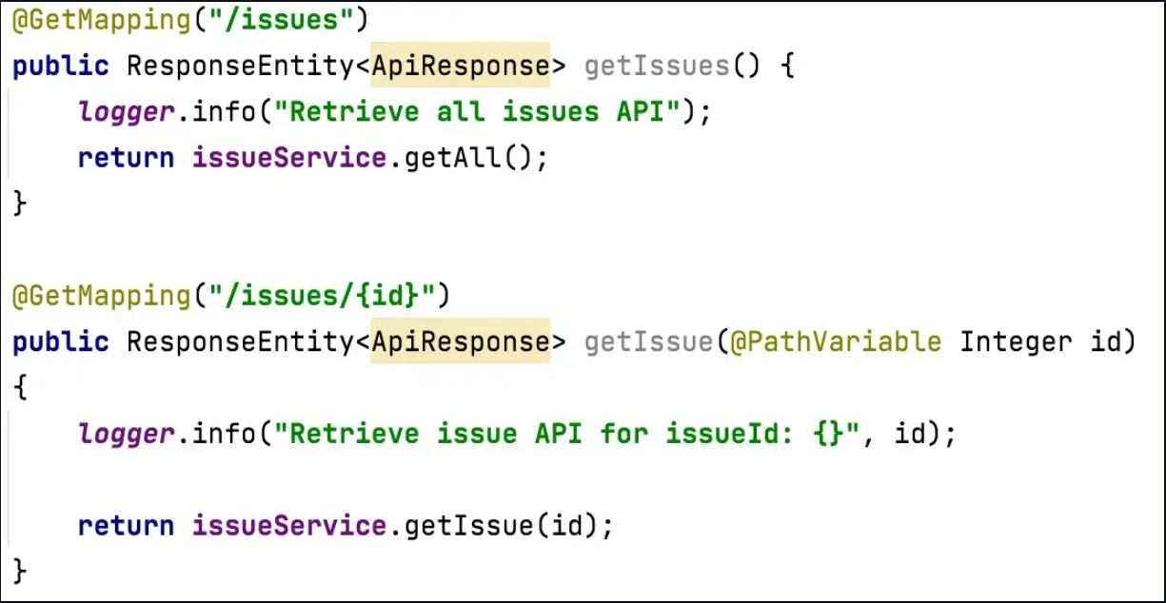

**24. Use SonarLint**

* This is very useful for identifying small bugs and best practices to avoid unnecessary bugs and code quality issues.
* You can install the plugin into your favorite IDE.